CSA0619-Design and Analysis of Algorithm

Title
Case Study: Online Advertisement Ranking Using Quick Sort
Problem Statement:
The main problem is to efficiently sort a large number of advertisements while considering the effect of pivot selection and input data distribution on Quick Sort performance.
The system should:
- Accept advertisement details.
- Calculate the ranking score.
- Sort advertisements using Quick Sort.
- Display advertisements in ranking order.
- Measure execution time.
- Analyse best, average, and worst-case performance.
- Identify possible optimization techniques.
Objective
The objective of this case study is to implement Quick Sort for ranking online advertisements based on their relevance score and bid value. The study demonstrates the divide and conquers approach of Quick Sort, analyses the effect of pivot selection and data distribution, measures execution performance, and discusses suitable optimizations for efficient advertisement ranking.

Ranking Score Calculation
Each advertisement contains:
- Advertisement ID
- Relevance Score
- Bid Value
The ranking score is calculated using:
Ranking Score = Relevance Score × Bid Value
For example:
Relevance Score = 8
Bid Value = 50
Ranking Score = 8 × 50= 400
Advertisements with higher ranking scores are placed at the top.
Quick Sort Algorithm
Quick Sort follows the divide and conquer approach.
Step 1: Divide
A pivot element is selected from the advertisement list.
Step 2: Partition
Advertisements with higher ranking scores are moved before the pivot, while advertisements with lower ranking scores are moved after it.
Step 3: Conquer
The left and right partitions are recursively sorted.
Step 4: Result
The advertisements become sorted in descending order of their ranking scores.

Source Code:
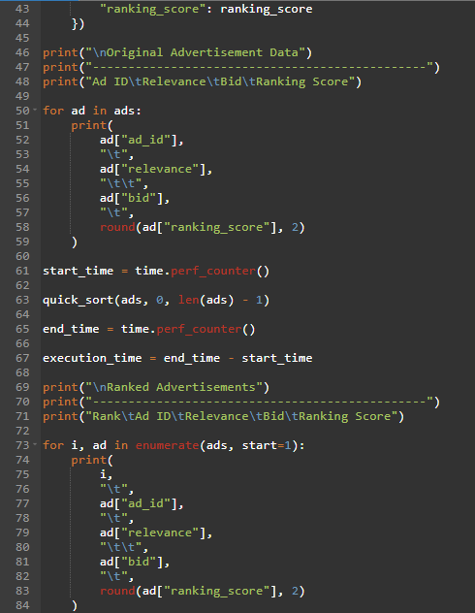
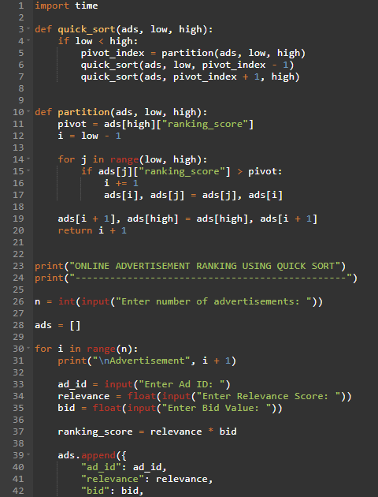

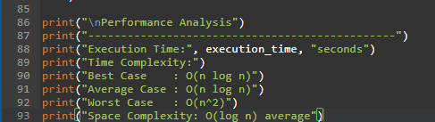

Output:
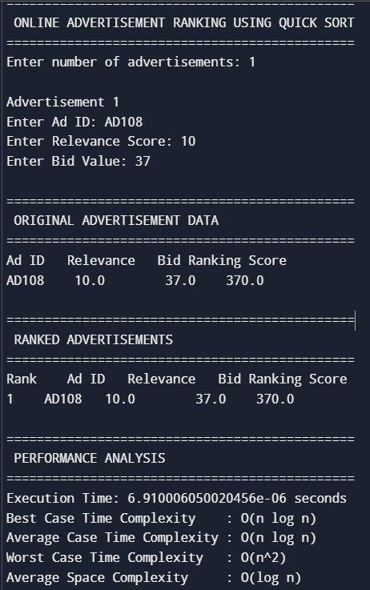
Case | Time Complexity

Best Case | O (n log n)

Average Case | O (n log n)

Worst Case | O(n²)

Space | O (log n)

Space Worst Case | O(n)

